**WEBSITE COVER PAGE**

Jasmine & Ashwin

Wedding Logo

1 - 3 DECEMBER, 2017

MUMBAI, INDIA

Enter Our World (Enter Button)

Off White Background & Pink Text with a Jasmine Flower on the edge

**WEBSITE MAIN PAGE**

“AJape Love!”

”What is agape love?"

The Greek word *agape* is often translated “love” in the New Testament. How is “agape love” different from other types of love? The essence of agape love is goodwill, benevolence, and willful delight in the object of love. Unlike our English word *love*, *agape* is not used in the New Testament to refer to romantic or [sexual love](https://www.gotquestions.org/eros-love.html). Nor does it refer to close friendship or [brotherly love](https://www.gotquestions.org/phileo-love.html), for which the Greek word *philia* is used. Agape love involves faithfulness, commitment, and an act of the will. It is distinguished from the other types of love by its lofty moral nature and strong character.

**Agape** ([Ancient Greek](https://en.wikipedia.org/wiki/Ancient_Greek) [ἀγάπη](https://en.wiktionary.org/wiki/%E1%BC%80%CE%B3%CE%AC%CF%80%CE%B7#Ancient_Greek), *agápē*) is a [Greco](https://en.wikipedia.org/wiki/Greeks)-[Christian](https://en.wikipedia.org/wiki/Christian) term referring to "love; the highest form of love, charity", and "the love of God for man and of man for God".[1] Not be confused with [philia](https://en.wikipedia.org/wiki/Philia), [brotherly love](https://en.wikipedia.org/wiki/Brotherly_love_(philosophy)), it embraces a universal, unconditional love that transcends, that persists regardless of circumstance.

PHOTO slide show (3 photographs) -

1. Family Photo with BELOVED DADA
2. Jasmine & Ashwin Photo (Ashwin & Jasmine Dressed in Black)

Marriage helps young couples to raise themselves towards God. The bond of marriage unites two souls so firmly that though they are physically two separate entities, their souls are merged into one harmonious whole. - Dada JP Vaswani

True love is selfless. It is prepared to sacrifice. - Dada JP Vaswani

True love bears all, endures all and triumphs! - Dada JP Vaswani

“True love is sacrifice. It is in giving, not in getting; in losing, not in gaining; in realizing, not in possessing, that we love!” - Dada JP Vaswani

“Spread love everywhere you go.  Let no one ever come to you without leaving happier.” - Mother Teresa

“Give without any thought of getting something in return.Give freely and unconditionally!” - confirm that it’s Beloved Dada’s quote

“Go out into the world today and love the people you meet. Let your presence light new light in the hearts of people. – Mother Teresa”

Love and compassion are necessities, not luxuries. Without them humanity cannot survive. - His Holiness Dalai Lama

**LINKS OFF THE MAIN PAGE**

INVITATION

FESTIVITIES

TRAVEL & RESERVATIONS

RSVP

**INVITATION:**

**WITH THE INFINITE BLESSINGS AND GRACE OF**

**REV. DADA J.P. VASWANI**

**Dr. Vijaylaxmi (Late) & Ashok Nariani Mamta & Ajit Gidwani**

**Jaya & Dr. Kamal Vazirani**

REQUEST THE PLEASURE OF YOUR COMPANY AT

THE MARRIAGE OF THEIR CHILDREN

Jasmine & Ashwin

**1 - 3 DECEMBER,2017**

**MUMBAI, INDIA**

IT WOULD BE AN HONOUR AND PRIVILEGE TO

HAVE YOU AMIDST US DURING THE CELEBRATIONS.

YOUR PRESENCE IS THE GREATEST GIFT OF ALL.

WITH THE LOVE & BLESSINGS OF

LATE DRUPADI & DR. ASSANDAS VAZIRANI

LATE GOPI & CHELLARAM NARIANI

JAYA & KAMAL VAZIRANI

PUSHI & SURESH LALWANI

VIMLA JAGASIA

GANGA & TARO VAZIRANI

SARUP & GIRDHARI NARIANI

NEENA & STEVE FREIBERG

**FESTIVITIES**

THURSDAY, NOVEMBER 30, 2017

The Janiya (Thread Ceremony) - Family Only

Venue: Home (11 Cooperage Road, Mumbai, 400 039)

Time: 5:00PM - 7:00PM

Attire: Ethnic

FRIDAY, DECEMBER 1, 2017

Bombay Nights

Venue: Gallops

Time: 7:30PM - 11:30PM

Attire: Bollywood Sensational

SATURDAY, DECEMBER 2, 2017

A White & Black Rendezvous

Venue: Wode House Club

182 Maharishi Karve Road, Nariman Point

Time: 7:30PM - 11:30PM

Attire: Casual White and Black (Western)

SUNDAY, DECEMBER 3, 2017

Heart-to-Heart, Tete-a-Tete

The Pheras

Venue: Aqaba

Club House, Peninsula Business Park,

Senapati Bapat Marg, Lower Parel

Time: 5:00PM - 7:00PM

Attire: Ethnic

Gateway to Love

The Reception

Venue: Aqaba

Club House, Peninsula Business Park,

Senapati Bapat Marg, Lower Parel

Time: 7:00PM - 11:30PM

Attire: Ethnic

**TRAVEL & RESERVATIONS**

HOTEL VENUE

**Vivanta by Taj - President**, 90 Cuffe Parade, Mumbai India 400005 +91 22 6665 0808

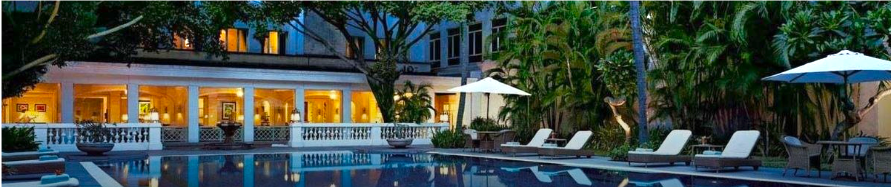

**Vivanta by Taj - President** has offered a special group rate for our guests and reservations can be made [here](http://meritagecollection.com/bacararesort/?_ga=1.54415592.197217502.1459974897). Click "BOOK NOW" and enter the group code **JASH** to view rates. You may also call +91 22 6665 0808 directly to book, as well. We encourage you to reserve early to ensure your choice of room.

Check-in time is 15.00 hours • Check-out time 12.00 hours.

**Group Code: JASH**

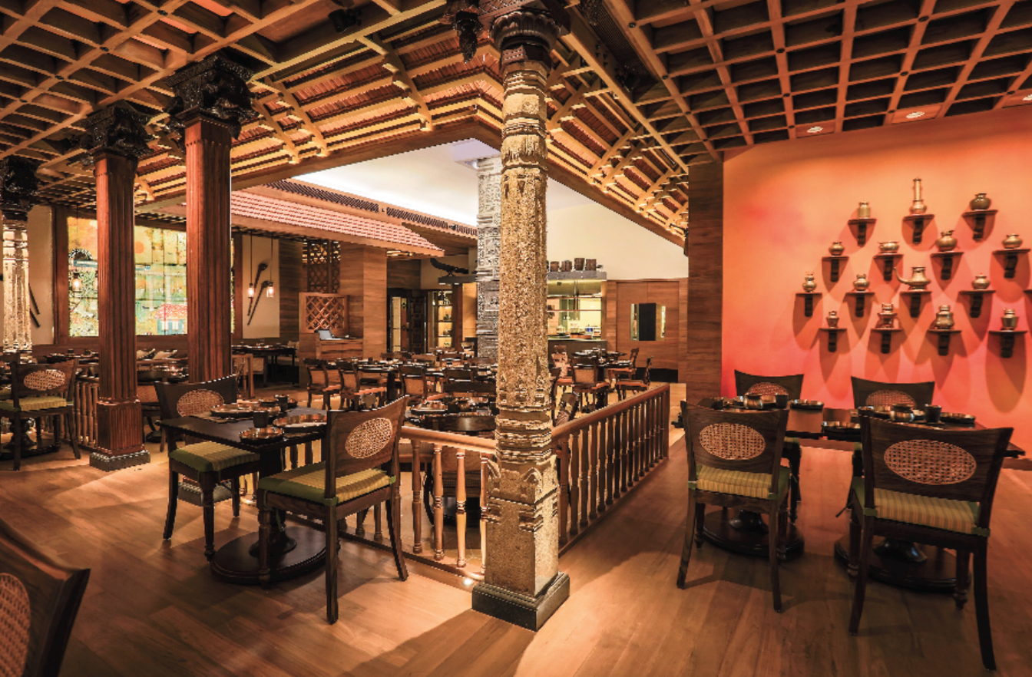

AIRPORT

Chhatrapati Shivaji International Airport (BOM)

182 Maharishi Karve Road, Nariman Point

Time: 7:30PM - 11:30PM

Attire: Casual White and Black (Western)

Google Map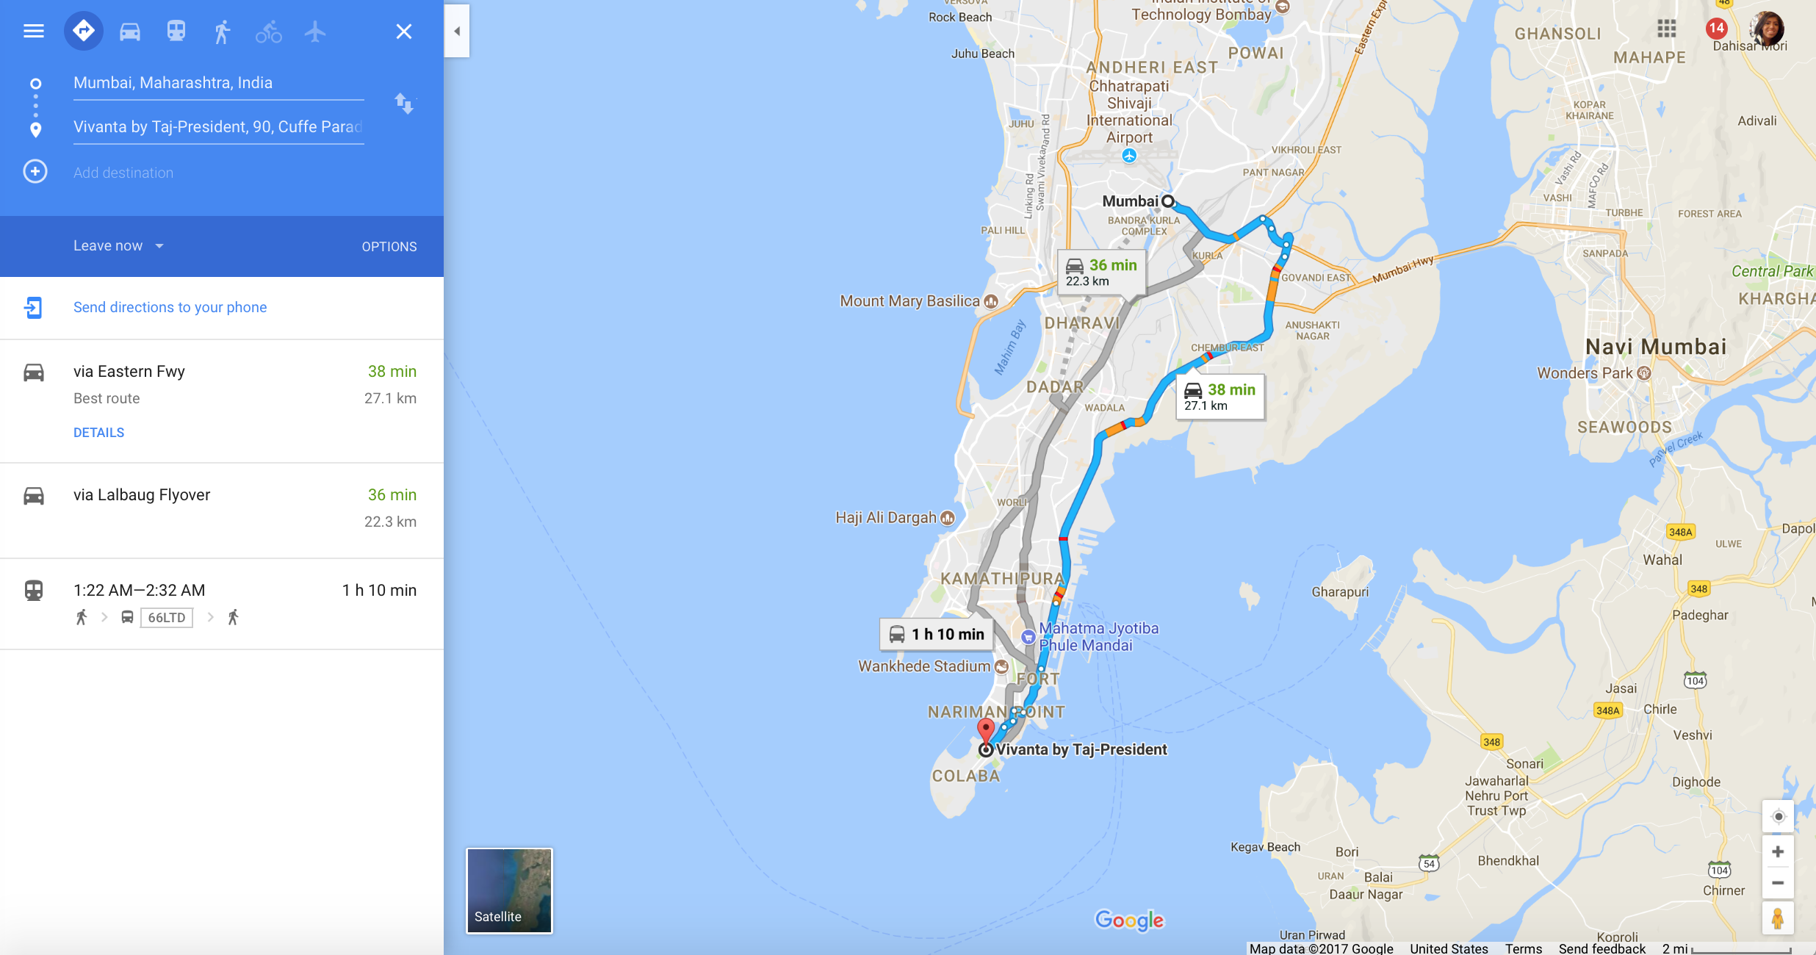

**RSVP**

Jasmine & Ashwin

Wedding Logo

“AJape Love!”

HOTEL RESERVATION FORM

Online Reservation form to be filled in before 25 October 2017

Guest 1: First Name: ____________________ Last Name: ____________________ Friday Saturday Sunday

Guest 2: First Name: ____________________ Last Name: ____________________ Friday Saturday Sunday

Guest 3: First Name: ____________________ Last Name: ____________________ Friday Saturday Sunday

Guest 4: First Name: ____________________ Last Name: ____________________ Friday Saturday Sunday

Guest 5: First Name: ____________________ Last Name: ____________________ Friday Saturday Sunday

Guest 6: First Name: ____________________ Last Name: ____________________ Friday Saturday Sunday

Contact Phone Number: ____________________ Drop-down menu: Mobile/Home

Email: ____________________

**PHOTOS FOR SLIDE S****HOW WITH QUOTES:**



